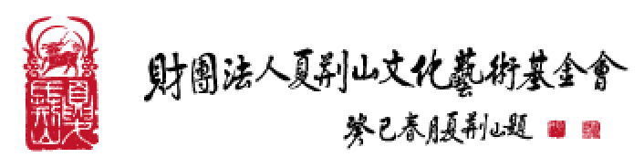
Letter of Undertaking

The Undersigned, _____________, has applied with the XIA JING SHAN Arts and Culture Foundation (the "Foundation") to obtain a license to use certain works in the collection of the Foundation (the "Works"). In order to protect the intellectual property rights in and to the Works, the Undersigned hereby represents and warrants that he/she/it will abide by the following terms and conditions:

- The Undersigned shall use the Works only within the scope of license approved by the Foundation in the "Application for the License to Use the Collection of the XIA JING SHAN Arts and Culture Foundation", shall comply with the "Guidelines Governing the Licensed Use of the Collection of the XIA JING SHAN Arts and Culture Foundation", and shall state the text, "Collection of XIA JING SHAN Arts and Culture Foundation" on an appropriate placement of the Works when using the Works. The Undersigned shall not disseminate, lease out, sell or assign the Works to others or do anything outside the scope of the license.
- No use of the Works shall violate the relevant laws and regulations, public order or good morals, or deviate from the scope of the license.
- Upon expiration or termination of the term of the license, the Undersigned shall forthwith return any and all files relevant to the Works to the Foundation and delete all copies thereof regardless of their format and shall not deliver the same to any third party.
- Unless otherwise agreed upon between the Parties, the Undersigned shall, within six months of the expiration of the term of the license, provide the Foundation with two copies of every product/work produced or created by the Undersigned based on the Works.
- If the Undersigned breaches any provisions of this Letter of Undertaking, the Undersigned shall be liable for damages to the Foundation, and the author of the Works and the Foundation may terminate the license. Upon termination of the license, the Undersigned may no longer disseminate, lease out, sell, assign or reproduce, and shall immediately destroy, any and all products/works and the samples thereof that are produced or created based on the Works. If any third party is in possession of any files relevant to the Works due to any cause attributable to the Undersigned, the Undersigned and such third party shall be jointly and severally liable for damages to the Foundation and the author of the Works.

To:

XIA JING SHAN Arts and Culture Foundation

If the license applicant is a natural person:

By: _____________ (signature or chop)
ID Card Number: _____________
Tel: _____________
Address: _____________
___________________________________________________________________________

If the license applicant is a legal person:

Name of the Legal Person: _____________ (chop)
Representative: _____________ (signature/chop)
Name: _____________
Title: _____________
Unified Business Number: _____________
Tel: _____________
Address: _____________

Date: _____________

